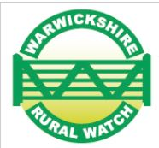
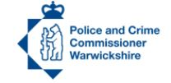
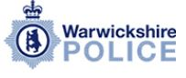

FARM MAPPING INITIATIVE

Data Protection Act and Telecommunications Act Authorisation Form

(Please use block capitals).

Full name of contacts (Mr/Mrs/Miss/Ms)

Forename___________________________ Surname_______________________________

Address ____________________________________________________________________________

___________________________________________________ Postcode________________

Email address :

Telephone No.:_________________________ Mobile No.: ___________________________

- I give Warwickshire Police the authority to place my details on a computerised database. I understand that the system is registered under the Data Protection Act and that my rights are protected.
Please refer to the Warwickshire Police Privacy Notice which can be found at :
https://www.warwickshire.police.uk/hyg/fpnwarwickshire/privacy-notice/.

- I agree that my details on this form can be held by Warwickshire Police so that I can be contacted if an incident affects my property / livestock / receive alerts and information relating to incidents, good news and meetings.

- I understand that the information on this form will be held for 12 months and I will then be contacted to see if it needs updating and / or I am happy to continue to be on this database.

- I understand that I can request to see what information is held on this database relating to myself at anytime and the person to contact is the Rural Crime Coordinator (details below).

Signed__________________________________ Date ___________________

OFFICER ________________________ EASTINGS ________________ NORTHINGS __________________

Carol Cotterill, Rural Crime Coordinator, Rural Crime Team, Warwickshire Police, c/o North Warwickshire Borough Council, South Street, Atherstone, CV9 1YN.
Email : carol.cotterill1@warwickshire.pnn.police.uk

Warwickshire Police would like to keep up to date contact details for your farm/stables so that they can contact you in an emergency

Please advise what kind of farm you have, i.e. dairy, arable, livestock, mixed, etc:

_____________________________________________________________________________

Parish Holding No.: ___________________ Flock No, _____________/ Herd No.: _____________

What livestock do you have:

Do you have farm units that businesses operate from? _________________________________

What type of businesses are they? ________________________________________________

Are you a member of Rural Watch /Horse Watch and receive alerts / have signage ___________

Would you like advice and information on crime prevention? _____________________________

Have you had problems with poaching / illegal metal detecting / livestock worrying.

Are you aware of the Rural Crime Team in Warwickshire Police ___________________________

Do you have any concerns that we can help you with? __________________________________

If you have land away from the main farm could you advise of its location.
This will help us if livestock escapes onto the highway, there is a traffic collision and your boundary is damaged, there is suspicious activity on your land or we need to access it in an emergency.
(Eastings and Northings are needed for all locations to put on the system).

THANK YOU FOR YOUR TIME AND SUPPORT

